CTM-I Use Case

Trade Message Maintenance

Version 0.2

Use Case Name | Trade Message Maintenance
Actor | Broker, Firm User, Market Ops, Ops, App Support
Pre-conditions /Assumptions | User has selected to edit the trade from the Trade Message Browse use case
Post Conditions | User can select to return to the Trade Message Browse screen by clicking on the “Return to Message screen” link.
Screenshot | 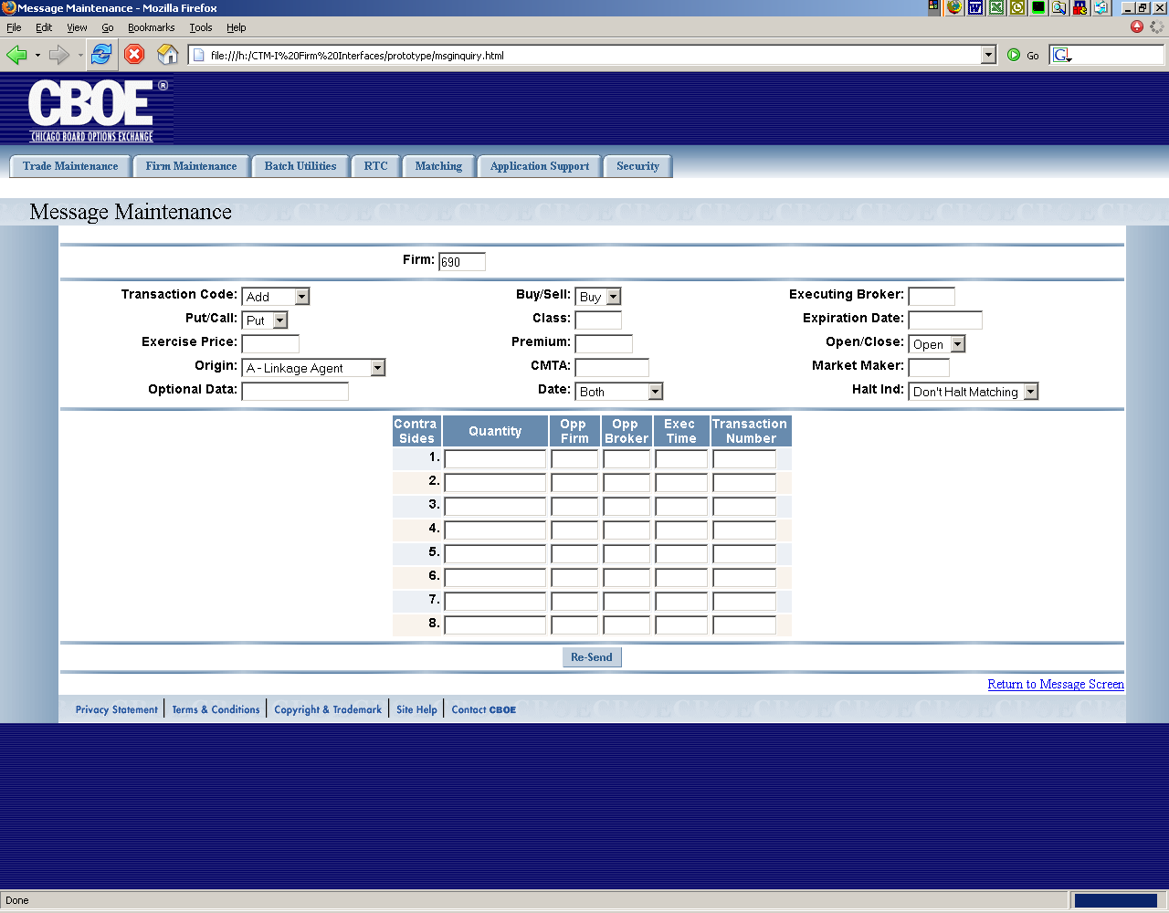
Flow of Events | - A request is sent to CTM-R to get the specific trade message information to display  - Trade Message Maintenance screen appears with data from CTM-R  - User can change the following fields  - Firm  - Firm defaults to the firm of trade message and is display only  - The editable firms is limited by security  - Transaction Code will be limited to “Add”, “Change” and “Delete”.  - Delete code should display a pop-up window to ask “Are you sure you want to delete this message?”, with a Yes or No function.  - Buy/Sell  - Buy/Sell will be limited to “Buy” and “Sell”.  - Only one selection may be made  - Executing Broker  - Put/Call  - Put/Call will be limited to “Put” and “Call”.  - Only one selection may be made  - Class  - Expiration Date (clear up)  - Exercise Price  - Premium Price  - Open/Close  - Open/Close will be limited to “Open” and “Close”.  - Only one selection may be made  - Origin  - Origin will be limited to “A – Linkage Agent”, “B – Broker Dealer”, “C – Customer”, “F – Firm”, “J – Joint BackOffice”, “M – Market Maker”, “N- Non-Market Maker”, “P – Linkage Account”, “S – Stock Specialist”, “Z – Other Non Raes”.  - CMTA  - Market Maker  - Optional Data  - Date  - Date will be limited to “Both”, “As of Date” and “Trade Date”.  - Only one selection may be made  - Halt indicator  - Halt Indicator will be limited to “Don’t Halt Matching” and “Halt Matching”.  - Only one selection may be made  - The trades that fit the criteria will be returned by CTM-R.  - The trades will be displayed in the Message Maintenance screen in a table format  - The Contra information will be display in a table format for up to seven contra.  - User will be allowed to return back to Message Browse.  - The re-send button will build the message into a trade and send it to CTM-R to process
Alternative Path | - After performing a search, the user can refresh the data at any time by pressing the search button.  - Any modification to a trade will cause a confirmation pop-up to occur if the user tries to leave the screen without saving their changes.  - Search Criteria and current page information will be available to other pages to return to the current search results.

